PRACTICE TASK CLASS -6
- word count
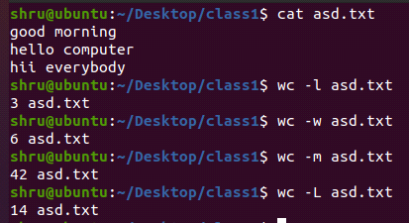
- create user, change password and check for user
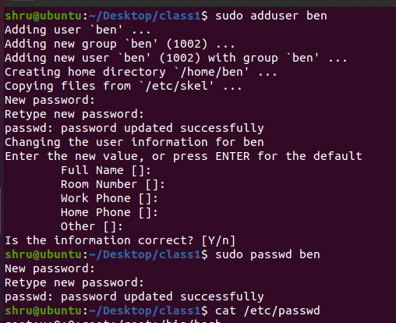

- create group and check for group

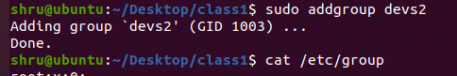

- switch to root user and particular user
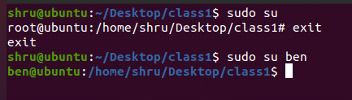
- add user to group and check for user group
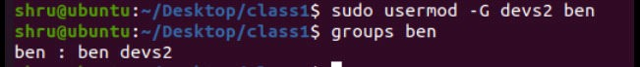
- delete user and delete group
